Date | 30 September 2026
Team ID | 6ab4dd7a6f290be8a6b49f92
Project Name | Script-Controlled ACL – Restrict Record Access Based on Field Value
Maximum Marks | 3 Marks

Figure 01. User Account Creation – EEE User

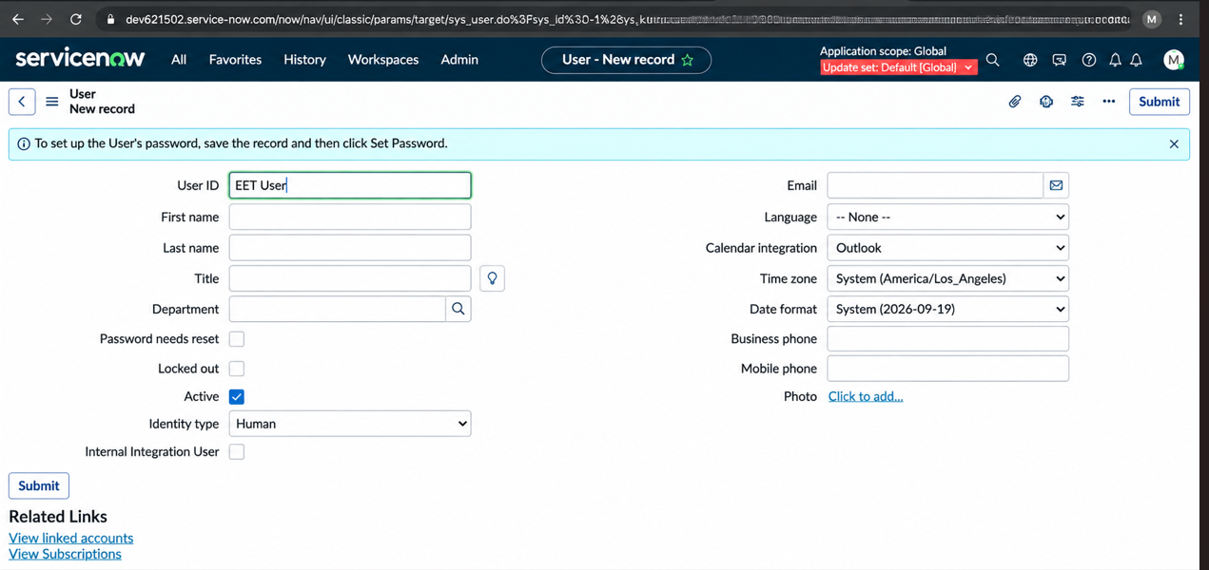

Figure 02. Institution Details Table – Initial Table Definition

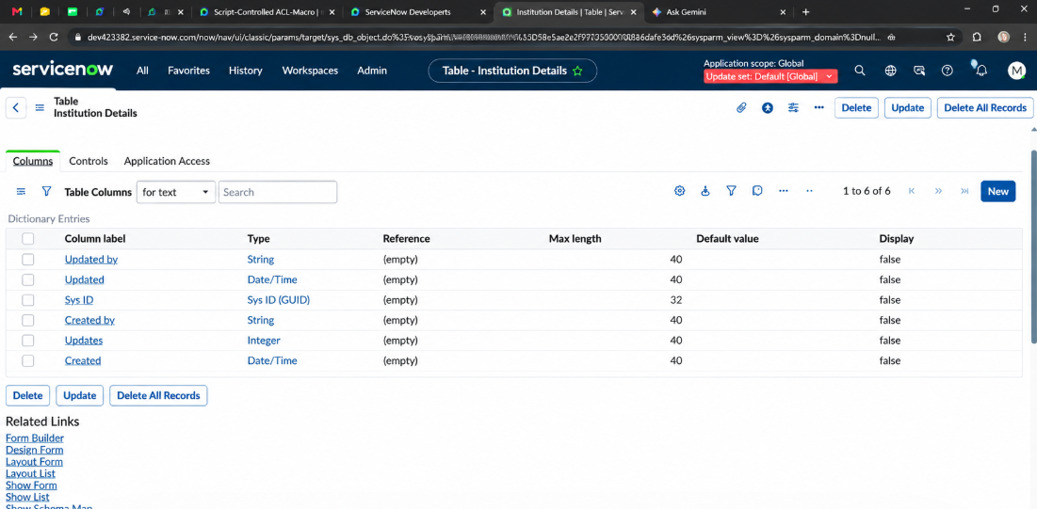
Figure 03. Institution Details Table – Student, Faculty and Roll Number Fields

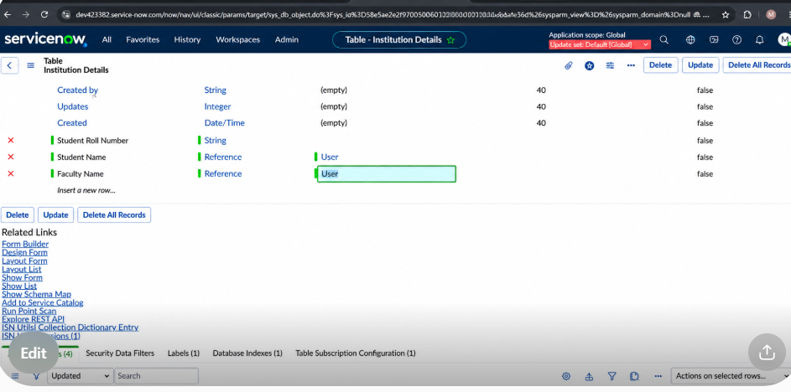

Figure 04. Institution Details Table – Complete Field Configuration
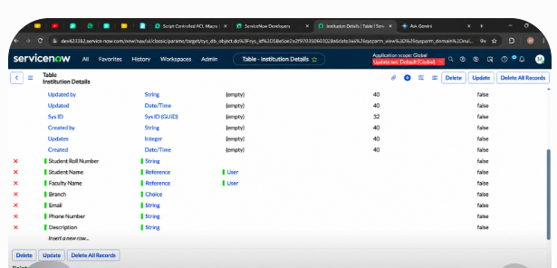

Figure 05. Creating an Institution Details Record

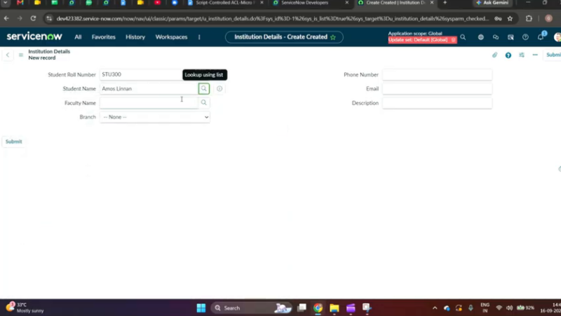

Figure 06. Institution Details – Records Created

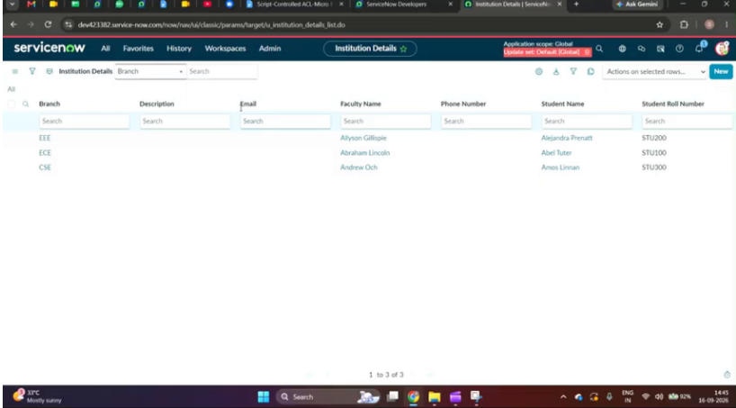

Figure 07. Access Control – New Record for Read Operation

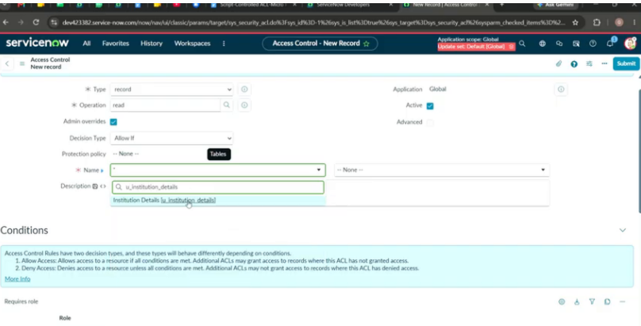

Figure 08. Script-Controlled ACL – Branch Condition and Authorization Script

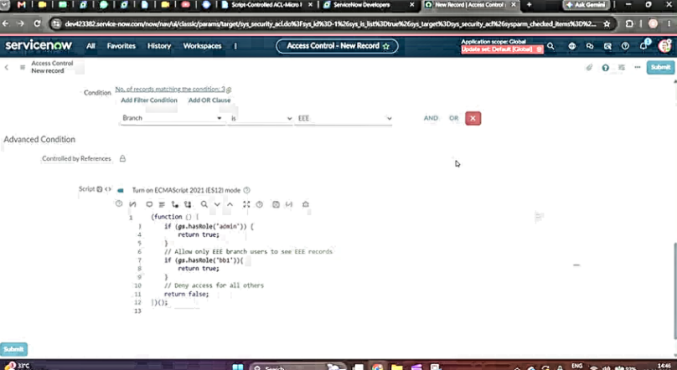

Figure 09. Access Control – Create Operation

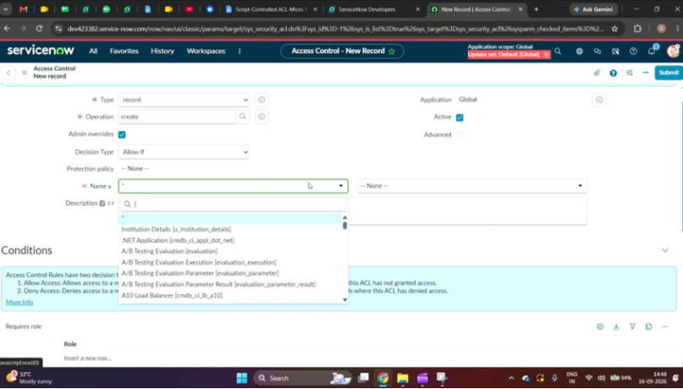

Figure 10. Access Control – Write Operation

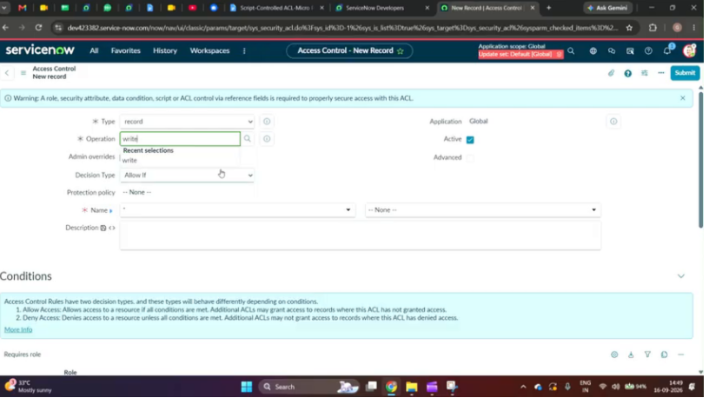

Figure 11. Verify Security Rules for Institution Details

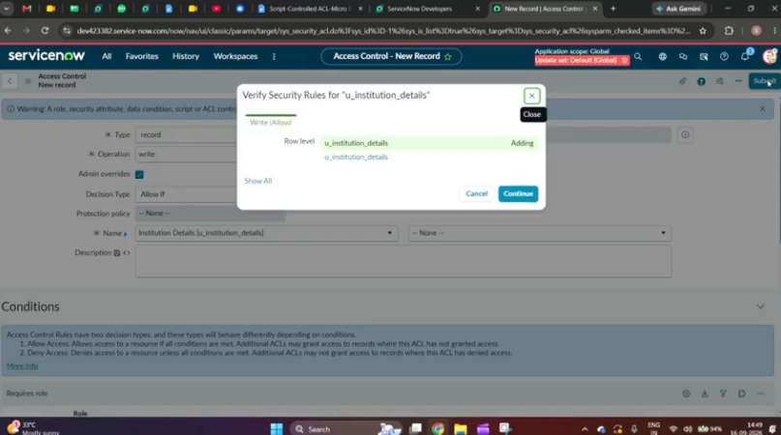

Figure 12. Access Controls – Created ACL Rules

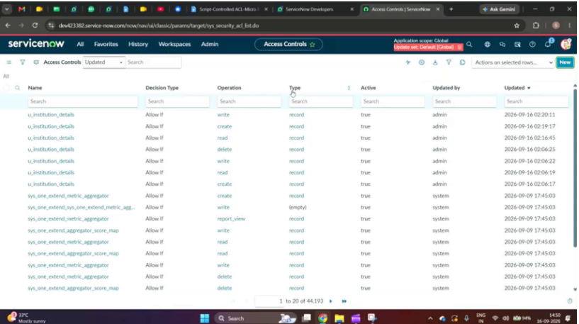

Figure 13. Administrator View – All Institution Details Records

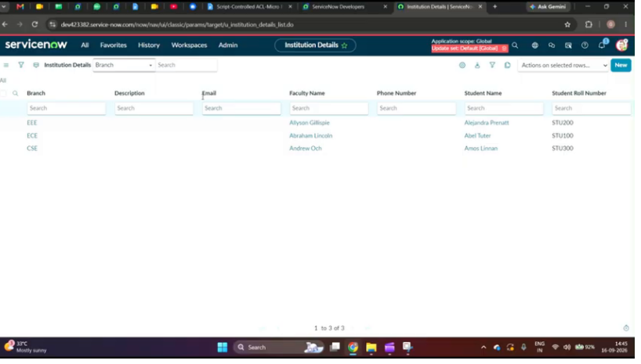

Figure 14. Expected Access-Control Results – Role-Based Record Visibility

